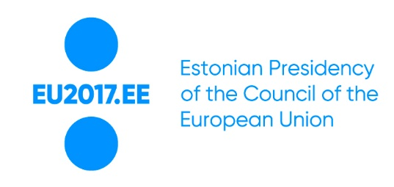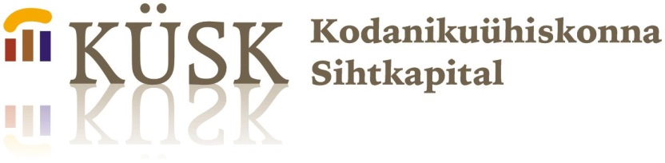
Contributing to taking into use the European Accessibility Act

The Estonian Chamber of Disabled People is in close co-operation with Estonian State Government Office, Estonian Ministry of Social Affairs and European Disability Forum from Mach until the end of the year implementing a project “Contributing to taking into use the European Accessibility Act”, supporting to bring the dossier onwards in frames of the Estonian Presidency of the Council of the European Union

The aim of the project is to support the Estonian Council presidency to progress with the draft EU Accessibility Act, to provide user expertise and ideas to facilitate the process. It is important to explain the Accessibility Act to the stakeholders – to secure as smooth as possible later transposition of the directive into national legislation. The draft directive is focusing on e-services such as e-commerce, self-service terminals, e-books, smart tools etc. to be accessible, also looking at how the accessible services will be reached for users in the built environment.

An important and major event in frames of the project will be an Accessibility Conference, to be held October 6th -7th 2017 in Narva and Tallinn. The Conference is featured in the official program of the Estonian Presidency of the Council of the European Union.

Holding the event in two cities will be securing the topic of accessibility to be addressed more largely across Estonia. We would like to reach as many decision makers as possible. Estonian Chamber of Disabled People has member organizations all over Estonia and we have experience of hosting big events in Tallinn but also outside the capital. The Estonian EU presidency accessibility conference is kicked-off in the 3rd largest Estonian city Narva on the 6th of October and will continue in Tallinn on the 7th of October.

Two days of the Conference will gather around 200 participants among which the activists of the disability movement and experts from many European Union member states, participants and speakers from the European Commission, Estonian public and private sector stakeholders and we are also expecting participants from the Russian Federation.
The project is backed up by 15 780 euros, of which EPIK co-funding is 3952 euro, total project budget is 19 732 euro. The overall cost of the initiative will be 56 700 euro, including the expensive travel and accommodation cost of guests arriving outside Estonia. The initiative is also backed up by Narva and Tallinn cities. Thanks a lot for all contributors.

The project is co-funded by Estonian Government Office in co-operation with National Foundation of Civil Society.

Text of the Accessibility Act in English

http://eur-lex.europa.eu/resource.html?uri=cellar:202aa1e4-99a0-11e5-b3b7-01aa75ed71a1.0021.02/DOC_1&format=PDF

Contacts:

Project manager: Meelis Joost, meelis.joost@epikoda.ee
Project team: Anneli Habicht anneli.habicht@epikoda.ee and Helen Kask helen.kask@epikoda.ee

